Airport Management System
Java Springboot 3.4.1

This project implements a simple management system for an airport in Java’s framework, Springboot 3.4.1. Its planned use is to manage the process of planning a flight and booking it through simple operations and validations.
Business requirements:
- The system should allow registering an aircraft with information about the model, the capacity and the number.
- The system should be capable of creating flights with details about the departure and arrival.
- Each flight should be associated to an airplane and a boarding gate.
- Each passenger should be uniquely identified based on a passport number.
- The system should be allow adding seats for each flight without exceeding the aircraft’s set capacity.
- A flight cannot be overbooked.
- Passengers should be able to access their bookings.
- The system should allow canceling a flight, deleting the booking and the seats associated to it.
- A passenger should be allowed to cancel their booking and their seat should become available.
- All data should be properly validated.
Main features for a minimum viable product:
- Flight management
- Passenger registration
- Booking system
- Data visualisation
- Data filtering

Each part of the project contributes to logic of the airport management system. Firstly, we have 6 entities: Aircraft, Flight, Passenger, Booking, Gate and Seat. The database was created in MySQL Workbench, and the tables were created by employing Hibernate through our project.

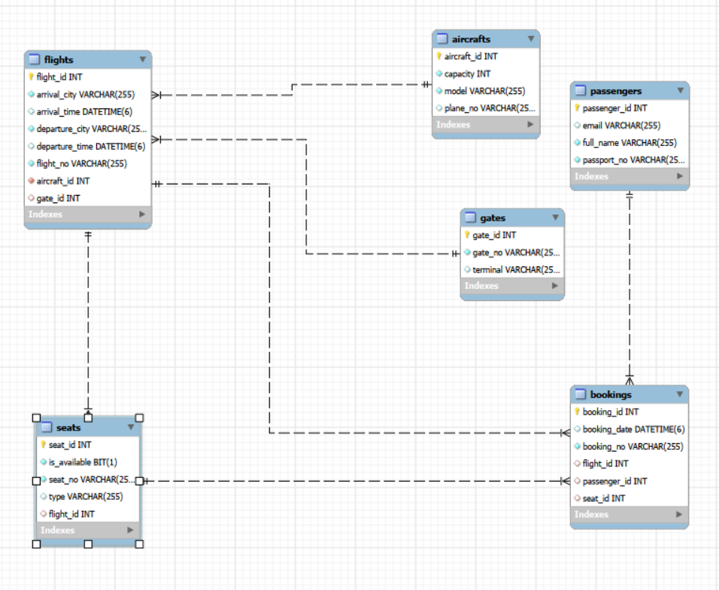
The ER diagram inserted above illustrated the existing tables and the relationships we established between the project entities.
To validate the data inserted in the database, we used jakarta.validation. We used @NotBlank for fields that can’t be null, @Min to set the plane’s capacity, @Future to validate the departure and arrival times, @Email to validate the email addresses of passengers and @Pattern for the passport number. This way, we ensure the integrity of the data and in the case of violating the validations, the response body will return informative errors for each case.
The core of the project consists in the two services created for flights and bookings, where the main logic of the administration system is being managed. We have methods for creating a booking that inserts a new row into the Bookings table and updates the seat to become unavailable when called, for getting passenger bookings and for canceling a booking. We also use a DTO class to simplify the body response after creating the booking. For flights, the service focuses on adding a new flight and either assign it the first available gate, or asking to pass a gate if the departure time is less than 40 minutes from the current time. We can see all flights, check the flight by flight number and by destination or delete a flight with all the reservations and the seats registered for it. For some of these methods, we use @Transactional when there are changes to data in more than a table at the same time so we can avoid having inconsistent, orphan data and, thus, errors.
All of these methods are being accessed through REST endpoints found in the BookingController and the FlightController, where we either pass the request parameters or the JSON body needed for the interrogations.
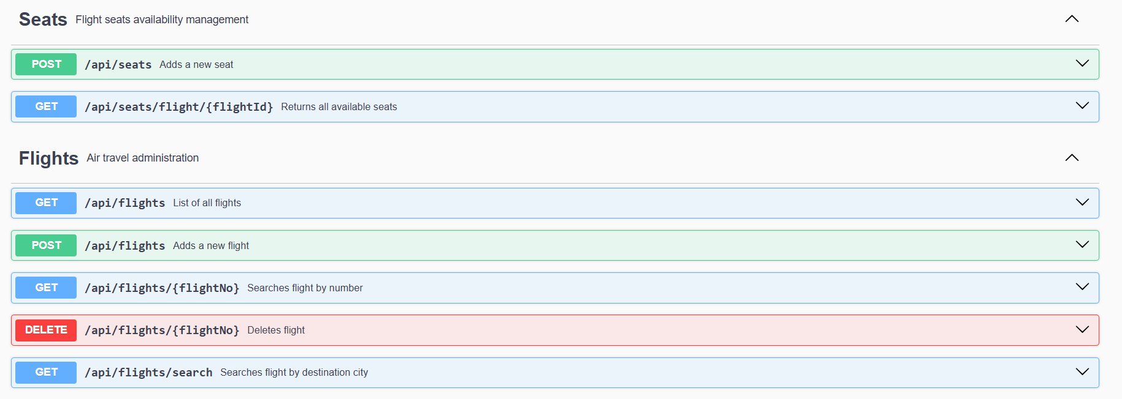
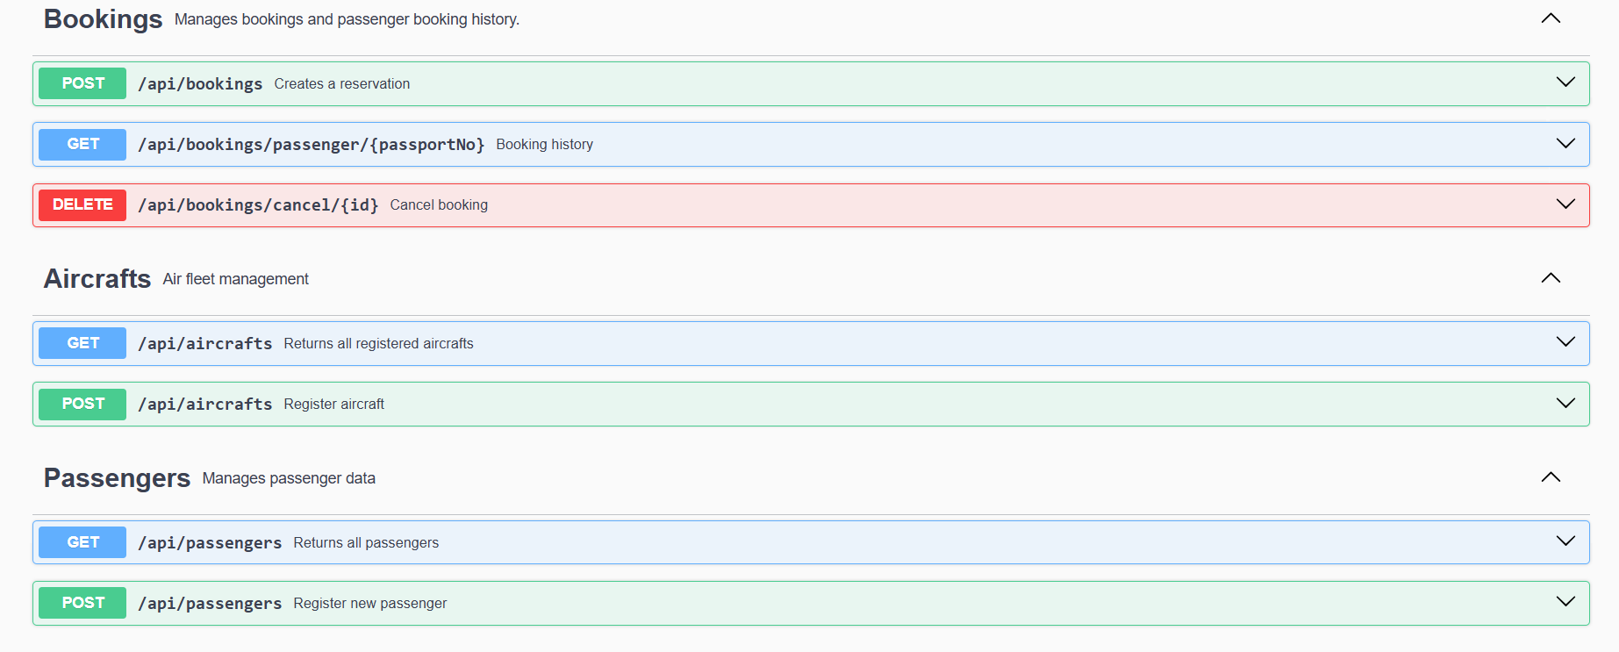
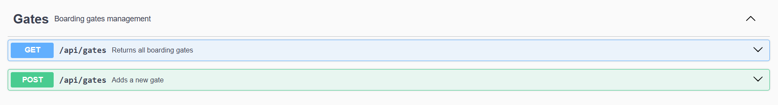
The rest of the services and the controllers focus on adding and viewing the data through the endpoints.
All of the communication between the services and the database is facilitated through JPA repositories for a better handling of the database querying, mostly using the standard methods and some custom ones for filtering.
The GlobalExceptionHandler class handles the rest of the bad responses from the server, treating business logic errors, validation errors and other server errors with a generalized error message. This way, the response bodies will be more readable and clear.
Unit testing is done with Mockito for services and MockMVC for controllers. We test the business logic of the project to check if everything works as intended in both the case of succes and failure. Mockito simulates an object without interaction with the database or other external services, while MockMVC is used to simulate HTTP requests to check the validations and the JSON mapping. All tests are passing at the moment of creating this documentation.

By employing all of these technologies, we implemented a rudimentary airport management system that can extend the functionalities even further. For example, as of now, when a booking is created it assigns the passenger the first available seat without taking into consideration the seat type. We can modify the method to take it into consideration and choose from either business class or economy class. Regardless, the project still demonstrates the use of Springboot framework to build the backend of a Java web application.

